1. Create a plugin using XrmToolBox.Extensibility namespace.
2. Download NuGetPackageExplorer from <https://npe.codeplex.com/>
3. Create a new package using NuGetPackageExplorer
4. Edit this file “replace name as per requirement”

<?xml version="1.0" encoding="utf-8"?>

<package xmlns="http://schemas.microsoft.com/packaging/2011/08/nuspec.xsd">

<metadata>

<id>RoleReplicator</id>

<version>1.2017.5.10</version>

<title>Role Replicator for XrmToolBox</title>

<authors>MscrmTools</authors>

<projectUrl>https://github.com/santoshCRM/RoleReplicator</projectUrl>

<iconUrl>https://raw.githubusercontent.com/wiki/MscrmTools/XrmToolBox/Images/logo_0100.png</iconUrl>

<requireLicenseAcceptance>false</requireLicenseAcceptance>

<description>Manage user roles, team and queues</description>

<summary>Manage user roles, team and queues</summary>

<releaseNotes>

</releaseNotes>

<tags>XrmToolBox Plugin RoleReplicator</tags>

<dependencies>

<dependency id="XrmToolBox" version="1.2016.11.4" />

</dependencies>

</metadata>

</package>

1. Login to <https://www.nuget.org/> and register or sign in.
2. Generate API key.

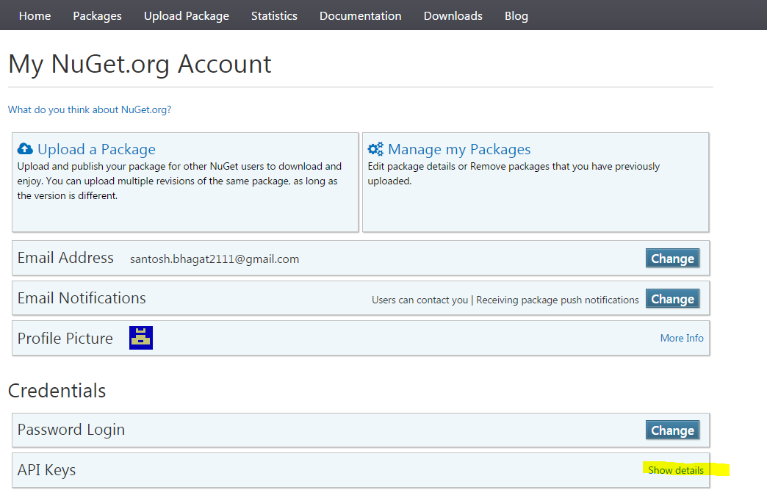

1. Create a folder in desktop with your project name and add lib->net452->Plugins->your dll
2. Add package in root folder.

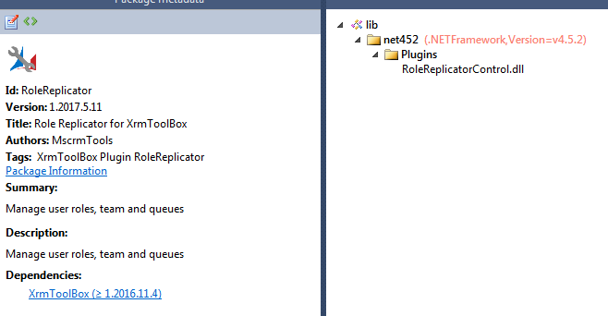

1. Click on File and select “Publish”

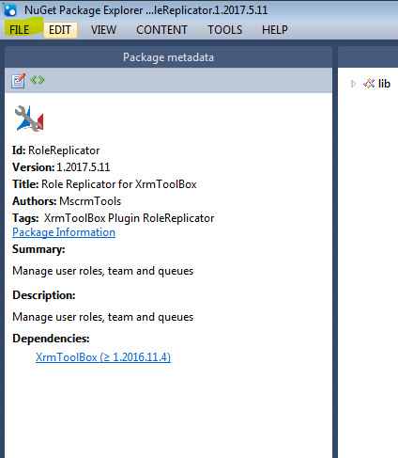

1. Enter the key and Publish.

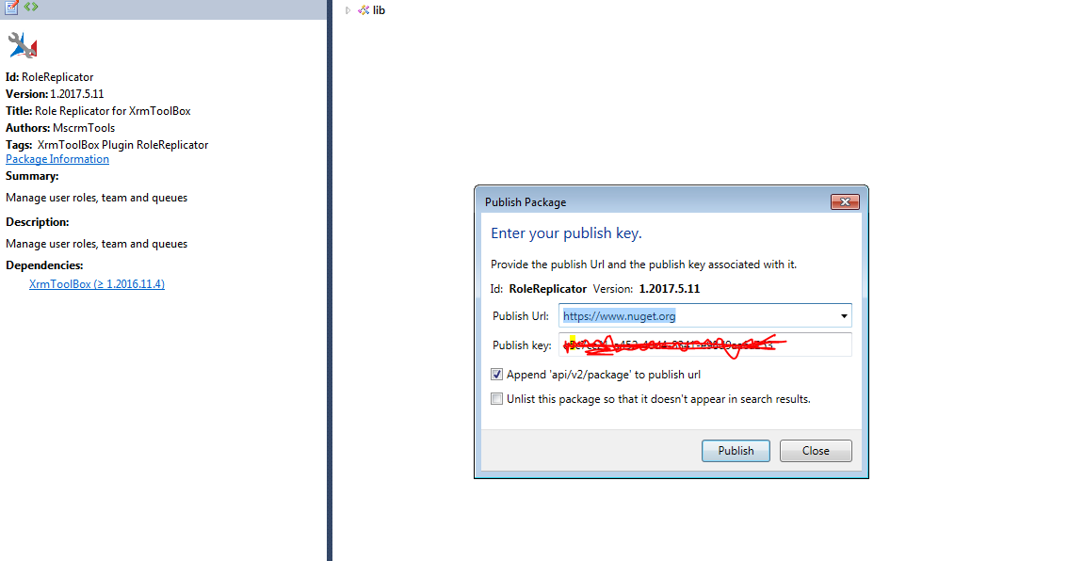

1. Now your dll will show in xrmtoolbox.

